1.TRAFFIC LIGHT
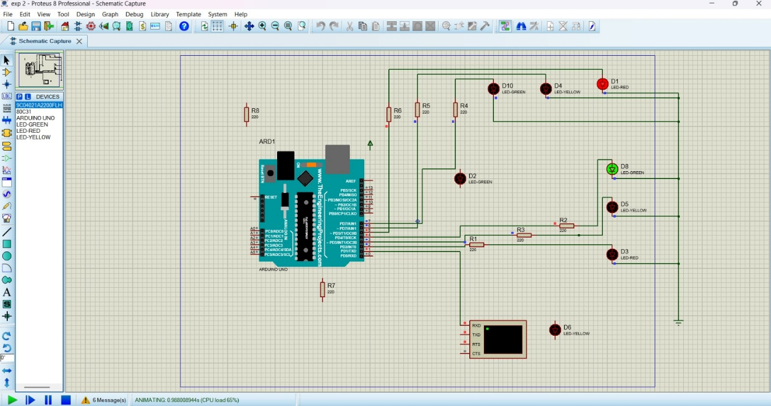
source code
// FSM-Based Traffic Light Controller
// Arduino UNO - Proteus 8 Professional

#define NS_RED 2
#define NS_YELLOW 3
#define NS_GREEN 4

#define EW_RED 5
#define EW_YELLOW 6
#define EW_GREEN 7

void setup()
{
pinMode(NS_RED, OUTPUT);
pinMode(NS_YELLOW, OUTPUT);
pinMode(NS_GREEN, OUTPUT);

pinMode(EW_RED, OUTPUT);
pinMode(EW_YELLOW, OUTPUT);
pinMode(EW_GREEN, OUTPUT);

Serial.begin(9600);
Serial.println("FSM TRAFFIC LIGHT CONTROLLER");
}

void loop()
{
// STATE S0: North-South GREEN
digitalWrite(NS_RED, LOW);
digitalWrite(NS_YELLOW, LOW);
digitalWrite(NS_GREEN, HIGH);

digitalWrite(EW_RED, HIGH);
digitalWrite(EW_YELLOW, LOW);
digitalWrite(EW_GREEN, LOW);

Serial.println("S0: NS GREEN - EW RED");
delay(10000);

// STATE S1: North-South YELLOW
digitalWrite(NS_GREEN, LOW);
digitalWrite(NS_YELLOW, HIGH);

Serial.println("S1: NS YELLOW - EW RED");
delay(3000);

// STATE S2: East-West GREEN
digitalWrite(NS_YELLOW, LOW);
digitalWrite(NS_RED, HIGH);

digitalWrite(EW_RED, LOW);
digitalWrite(EW_GREEN, HIGH);

Serial.println("S2: NS RED - EW GREEN");
delay(10000);

// STATE S3: East-West YELLOW
digitalWrite(EW_GREEN, LOW);
digitalWrite(EW_YELLOW, HIGH);

Serial.println("S3: NS RED - EW YELLOW");
delay(3000);

digitalWrite(EW_YELLOW, LOW);
}

2.HEALTH MONITORING
SOURCE CODE :
#include <Wire.h>

#define LM75_ADDRESS 0x48
#define PULSE_PIN 8

unsigned long pulseCount = 0;
unsigned long lastTempTime = 0;
unsigned long lastBpmTime = 0;

int previousPulseState = LOW;

float readTemperature()
{
Wire.beginTransmission(LM75_ADDRESS);
Wire.write(0x00);
Wire.endTransmission();

Wire.requestFrom(LM75_ADDRESS, 2);

if (Wire.available() >= 2)
{
byte msb = Wire.read();
byte lsb = Wire.read();

int16_t rawTemperature =
((int16_t)msb << 8) | lsb;

return rawTemperature / 256.0;
}

return -999.0;
}

void setup()
{
Serial.begin(9600);
Wire.begin();

pinMode(PULSE_PIN, INPUT);

Serial.println("I2C HEALTH MONITORING NODE");
Serial.println("---------------------------");
}

void loop()
{
unsigned long currentTime = millis();

// Pulse counting
int currentPulseState = digitalRead(PULSE_PIN);

if (currentPulseState == HIGH &&
previousPulseState == LOW)
{
pulseCount++;
}

previousPulseState = currentPulseState;

// Temperature acquisition every 1 second
if (currentTime - lastTempTime >= 1000)
{
lastTempTime = currentTime;

float temperature = readTemperature();

Serial.print("Temperature: ");

if (temperature > -100)
{
Serial.print(temperature, 1);
Serial.println(" C");
}
else
{
Serial.println("Sensor Error");
}
}

// BPM calculation every 5 seconds
if (currentTime - lastBpmTime >= 5000)
{
lastBpmTime = currentTime;

float bpm = (pulseCount * 60.0) / 5.0;

Serial.print("Pulse Rate: ");
Serial.print(bpm, 0);
Serial.println(" BPM");

Serial.println("---------------------------");

pulseCount = 0;
}
}

